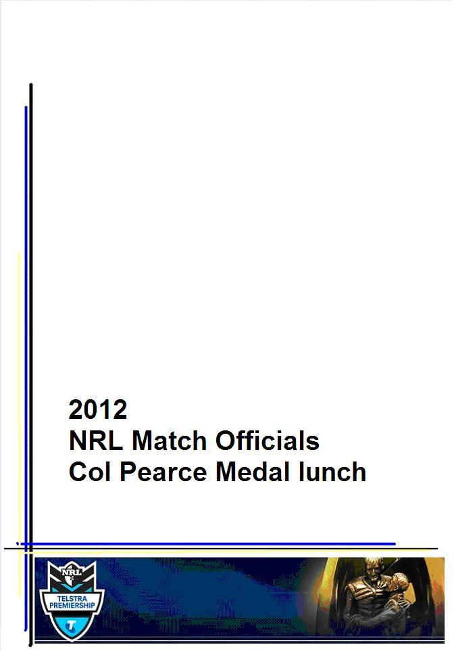

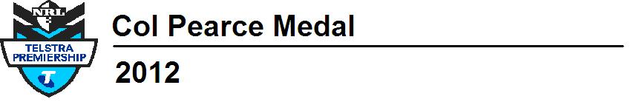

Welcome

Welcome to the 2012 Col Pearce Medal lunch.

This is the 9th year that we have recognised our most outstanding official with the awarding of the Col Pearce Medal. The medal is judged by the coaching staff and awarded to the most consistent and best referee throughout the full 26 rounds of the Telstra Premiership.

We are honoured to again welcome Mrs May Pearce, who will present the award today.

Today, we will also recognise other achievements from throughout the year.

We would like to thank all officials, coaching and medical staff for all their efforts this Season. We would also like to thank and acknowledge our sponsors - AAMI, OPSM, FI-TA, BSC Compression and the Sydney Olympic Park Authority.

We hope you have a most enjoyable afternoon.

Stuart Raper & Bill Harrigan

Photo Acknowledgement:

Thanks to George Jankowsi and NSW Rugby League Referees for the images and on-going support of the NRL Referees Squad.

2012 Match day officials:

No. | Name | No. | Name
4 | Steve Clark | 93 | Adam Devcich
6 | Paul Simpkins | 94 | Bernard Sutton
7 | Sean Hampstead | 95 | Brett Suttor
29 | Phil Cooley | 96 | Phil Haines
34 | Chris Ward | 97 | Daniel Eastwood
49 | Rod Lawrence | 98 | Gavin Reynolds
51 | Tony Archer | 99 | Luke Potter
52 | Matt Cecchin | 100 | Ricky McFarlane
53 | Steve Lyons | 101 | Ashley Klein
55 | Shayne Hayne | 102 | Adam Reid
58 | Steve Carrall | 103 | Grant Atkins
62 | Pat Reynolds | 104 | Gavin Morris
63 | David Abood | 105 | Luke Phillips
64 | Russell Turner | 106 | Henry Perenara
69 | Paul Holland | 107 | David Munro
70 | Gerard Sutton | 108 | Adam Gee
71 | Gavin Badger | 109 | Michael Wise
72 | Jeff Younis | 110 | Clayton Sharpe
73 | Jason Robinson | 111 | Gavin West
79 | Ben Cummins | 112 | Chris Butler
80 | Brendan Wood | 113 | Paul Mellor
81 | Tony De Las Heras | 114 | Nick Morel
84 | Russell Smith | 115 | Shane Rehm
85 | Jason Walsh | 116 | Peter Gough
87 | Alan Shortall | 117 | Nick Beashel
89 | Jared Maxwell | 118 | Dave Ryan
92 | Chris James | 119 | Jay Farlow

Coaching, training and support staff

Head Coaches:
Bill Harrigan & Stuart Raper

Match Officials coaches and match reviewers:
Russell Smith Paul Simpkins Sean Hampstead Pat Reynolds

Referee Operations Manager:
Don Stuart

Training & conditioning staff:
Klinton Hoare  Performance Manager | Tommy Wilson Assist Performance Mgr | Matt Green  Physiotherapist

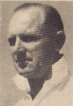 |  | Colin Frederick Pearce  Col Pearce was born in Newtown in 1917. He is one of the most widely known and widely respected referees in the history of Rugby League.  Col was originally more interested in cricket but that changed to Rugby League due to his fascination with the rules and interpretations of the rules of the game.  He began refereeing in 1946, debuting in first grade just one season later in 1947. He enjoyed a career of 343 first grade games.
He took charge of nine test matches between 1960 and 1967, three World Cup matches in 1968 and six Grand Finals, his first being in 1955 and then the others between 1964 and 1968.

He was authoritative yet he allowed the game to flow. He had a keen relationship with the players where they would show him respect due to his fair and consistent decision making. His motto was that Rugby League referees should "eat, sleep and drink the rules of Rugby League." |  |  | 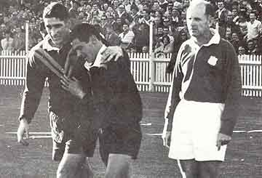
In Gregory's Guide to Rugby League (1965) Pearce explained the basis of an excellent philosophy: the importance to remain unnoticed on the field and help the players to turn on a good show for spectators.
"By this, I don't mean the referee should make himself the centre of attraction. In fact, the reverse is true. Of all the men on the field the referee should be the most unobtrusive. The less the spectators notice the referee, the better he is."

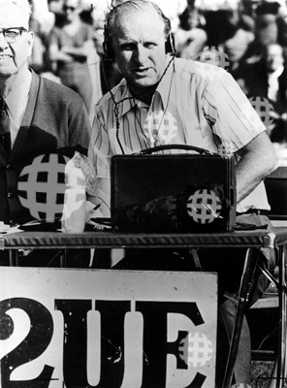 | In 1951, He was elected to the Rugby League Referee's Examination Board.  After his retirement from Rugby League refereeing he had a long career as a Rugby League commentator in the Sydney electronic and print media, with 2UE, Channel 7 and the Sydney Morning Herald.  Pearce passed away from pneumonia on 10 June 2004, aged 86

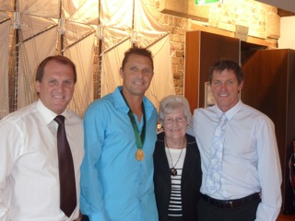

2011 Col Pearce Medal Winner, Shayne Hayne with May Pearce, Bill Harrigan & Stuart Raper

Col Pearce Medal
2004 | Tim Mander | Awarded to the most consistent and best-performed referee throughout the full 26 competition rounds and representative season.
2005 | Paul Simpkins
2006 | Steve Clark
2007 | Tony Archer
2008 | Tony Archer
2009 | Shayne Hayne
2010 | Tony Archer
2011 | Shayne Hayne
2012 | Ben Cummins

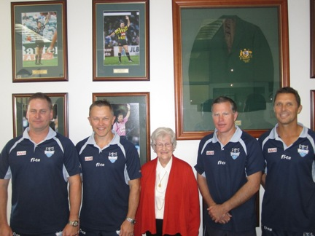

The Col Pearce Wall, officially opened in 2012 by May Pearce.
May is photographed here with all previous winners of the Award.

Clubman of the year
2003 | Tony Archer | Awarded to any squad or management member who contributes to the enhancement of the NRL squad through their commitment and dedication, internally and externally.
2004 | Jason Robinson
2005 | Paul Kalina
2006 | Steve Nash
2007 | Michael Stone
2008 | Klinton Hoare
2009 | Ben Cummins
2010 | Russell Smith
2011 | Gavin Badger
2012

Bill Harrigan Achievement Award
2003 | Sean Hampstead | Awarded to any squad member who reaches a significant milestone or an outstanding achievement throughout the season. An achievement may include overcoming an adversity to reach a goal
2004 | Steve Chiddy
2005 | Graeme West
2006 | Ben Cummins
2007 | Russell Turner
2008 | Jason Robinson
2009 | Gavin Badger & Jared Maxwell
2010 | Chris Ward
2011 | Phil Haines
2012 | Phil Cooley and Steve Clark

Rookie of the year
2006 | Ben Cummins | Awarded to any official with minimal experience in previous years, where they excelled within the current season.
2007
2008 | Alan Shortall
2009
2010 | Ricky McFarlane
2011 | Adam Devcich
2012 | Gavin Morris

Touch Judge of the year |  | Awarded to the most consistent and best performed TJ through 26 rounds and rep season.
2010 | Paul Holland
2011 | Daniel Eastwood
2012

Match Officials Officials Award
2008 | Jason Robinson | Awarded to the squad member who contributes the most to the squad on and off the field. Voted by the squad members
2009
2010 | Gerard Sutton
2011 | Ben Cummins
2012 | Ben Cummins

Match Official milestones

300 CLUB
2008 | Chris Ward – Video Referee
2008 | Graeme West – Video Referee
2010 | Steve Chiddy – Touch Judge
2012 | Steve Carrall – Touch Judge

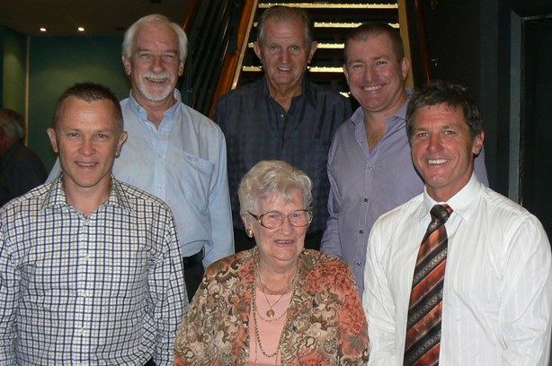

“Men of League 300 Club” recipients, 2012
Recipients included pre-NRL officials as well – Steve Clark, Bill Harrigan, Max Thomsett & Steve Betts

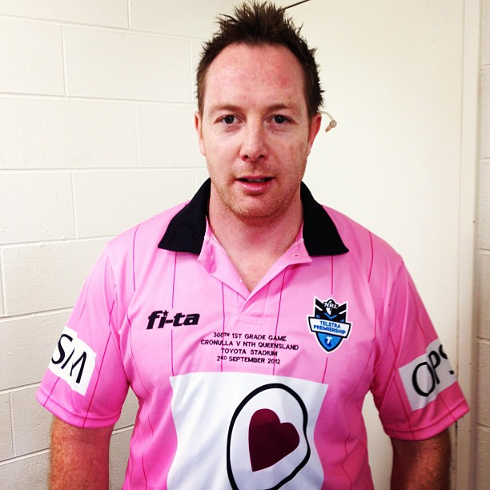

Newest 300 Club Member 2012 – Steve Carrall

200 CLUB
2005 | Tim Mander – Referee
2005 | Paul Simpkins – Referee
2006 | Sean Hampstead – Referee
2006 | Steve Clark – Referee
2009 | Tony Archer – Referee
2009 | Shayne Hayne – Referee
2009 | Phil Cooley – Video Referee
2009 | Russell Turner – Touch Judge
2009 | David Abood – Touch Judge
 | Steve Carrall – Touch Judge
2010 | Paul Holland – Touch Judge
2011 | Tim Mander – Video Referee
2012 | Jeff Younis – Touch Judge

100 CLUB
2001 | Bill Harrigan – Referee
2001 | Steve Nash – Touch Judge
2001 | Phil Cooley – Touch Judge
2001 | Ian Parnaby – Video Referee
2001 | John Gocher – Video Referee
2003 | Paul Kalina – Touch Judge
2003 | Eddie Ward – Video Referee
2004 | Darren Gocher – Touch Judge
2004 | Pat Reynolds – Touch Judge
2004 | Allan Foster – Touch Judge
2004 | Mick Stone – Video Referee
2006 | Matthew Cecchin – Touch Judge
2007 | Rod Lawrence – Touch Judge
2008 | Jeff Younis – Touch Judge
2008 | Michael Jones – Touch Judge
2009 | Jason Robinson – Referee
2009 | Bill Harrigan – Video Referee
2009 | Steve Clark – Video Referee
2010 | Steve Lyons – Referee
2010 | Gavin Badger – Referee
2010 | Ben Cummins – Referee
2010 | Jared Maxwell – Referee
2011 | Matt Cecchin – Referee
2011 | Russell Smith – Video Referee
2011 | Sean Hampstead – Video Referee
2012 | Jason Walsh – Touch Judge
2012 | Tony DeLas Heras – Referee
2012 | Russell Smith – Video Referee
2012 | Ashley Klein – Referee

Debutante – Welcome to First Grade:

#119 Jay Farlow
New South Wales Rugby League Touch Judge
First Grade Touch Judge debut in Round 23, Eels vs Roosters

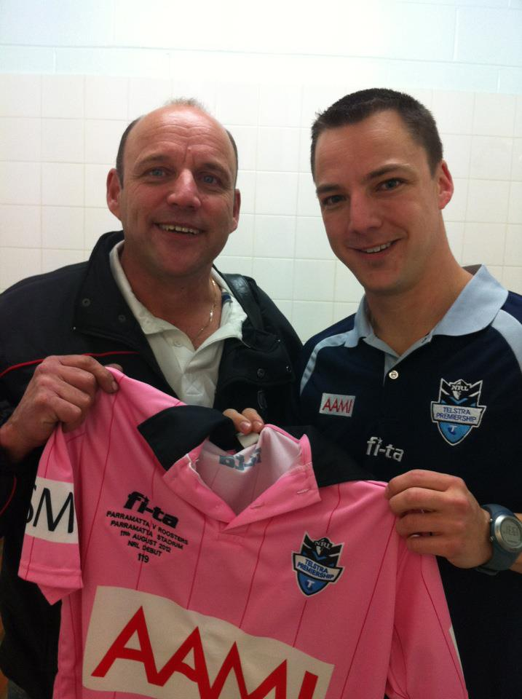

Retirements – Thank you for your contribution:

#5 Steve Chiddy
At the conclusion of the 2011 NRL season, the last of the still active “on field” match officials from the first round of the NRL in 1998.
12 Central Referee
325 Touch Judge
1 Video Referee

#8 Tim Mander
During the season, Tim retired from the match officials squad after winning a seat in the 2012 Queensland State elections.
292 Central Referee
210 Video Referee
End of 2011 major fixtures:
We acknowledge the following NRL members for their success at the conclusion of the 2011 NRL season:

2011 National Rugby League Grand Final
Referees: Matt Cecchin & Tony Archer
Touch Judges: Daniel Eastwood & Paul Holland
Video Referees: Russell Smith & Sean Hampstead

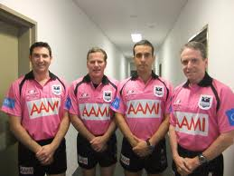

2011 Toyota Cup Grand Final
Referee: David Munro
Touch Judges: Henry Perenara & Luke Phillips
Video Referee: Steve Clark

2011 Four Nations Tournament, United Kingdom
Referees: Matt Cecchin (AUS) & Henry Perenana (NZ)
Touch Judge: Paul Holland (AUS)
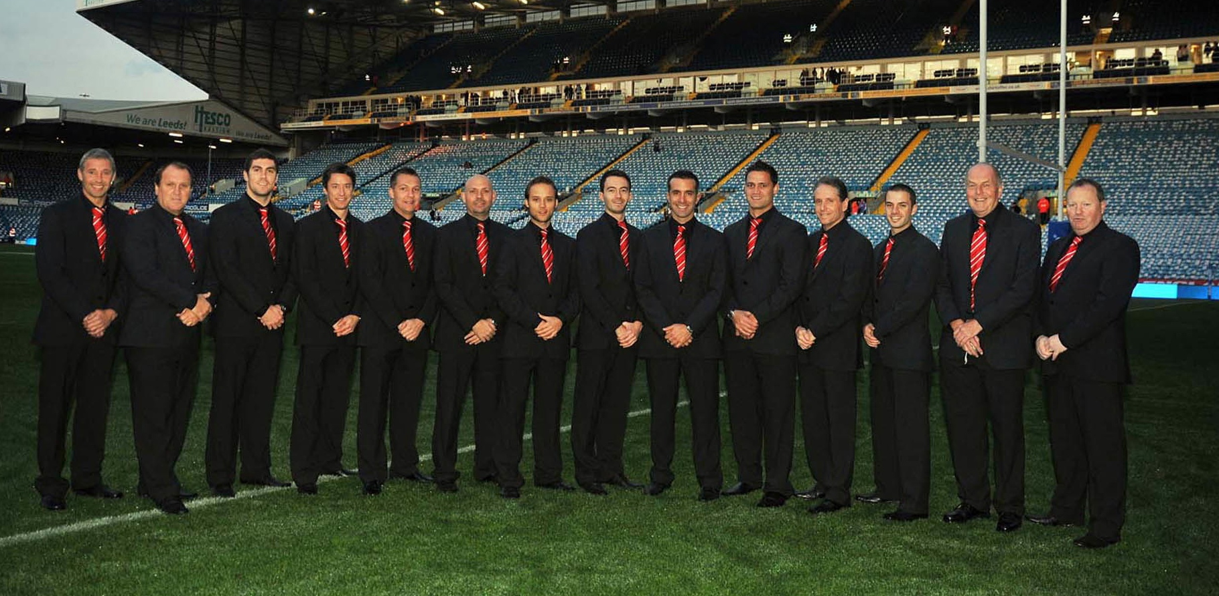
2012 Representative appointments:

Australia vs New Zealand
Eden Park, Auckland, New Zealand
20 April, 2012
Referee: Richard Silverwood (UK)
Touch Judges: Jeff Younis (AUS) & Aaron Kesha (NZ)
Video Referees: David Pakieto (NZ) & Russell Smith (UK)

City vs Country
Glen Willow Regional Sports Stadium, Mudgee, NSW
22 April, 2012
Referees: Gerard Sutton & Brett Suttor
Touch Judges: Adam Reid & Jason Walsh
Video Referee: Bernard Sutton

State of Origin I
Queensland vs New South Wales
23 May, 2012
Etihad Stadium, Melbourne
Referees: Ben Cummins & Matt Cecchin
Touch Judges: Jeff Younis & Paul Holland
Video Referee: Sean Hampstead

State of Origin II
New South Wales vs Queensland
13 June, 2012
ANZ Stadium, Sydney
Referees: Ben Cummins & Tony Archer
Touch Judges: Russell Turner & David Abood
Video Referees: Steven Clark & Paul Simpkins

State of Origin III
Queensland vs New South Wales
4 July, 2012
Suncorp Stadium, Brisbane
Referees: Ben Cummins & Tony Archer
Touch Judges: Russell Turner & David Abood
Video Referees: Steven Clark & Russell Smith

Prime Ministers XIII
Australia vs Papua New Guinea
23 September, 2012
Port Moresby, PNG
Referee: Phil Haines

Single discipline milestones

300 games

Steve Carrall – Touch Judge

250 games

Paul Holland – Touch Judge

200 games

Jeff Younis – Touch Judge

150 games

Steve Lyons – Referee
Gavin Badger – Referee
Ben Cummins – Referee
Jared Maxwell – Referee
Paul Simpkins – Video Referee

100 games

Ashley Klein – Referee
Tony De Las Heras - Referee
Jason Wash – Touch Judge
Russell Smith – Video Referee
50 games

Chris James - Referee
Phil Haines - Referee

Multiple discipline milestones

550 combined games

Chris Ward
136 Referee & 414 Video Referee

500 combined games:

Steve Clark  314 Referee & 186 Video Referee | Phil Cooley  30 Referee, 194 Touch Judge & 276 Video Referee
400 combined games:

Sean Hampstead
290 Referee & 110 Video Referee

300 combined games:

Tony Archer  292 Referee & 8 Touch Judge | Matt Cecchin  134 Referee & 166 Touch Judge
250 combined games:

Steve Lyons
155 Referee & 95 Touch Judge

200 combined games:

Gavin Badger  163 Referee & 37 Touch Judge | Jason Robinson  188 Referee & 12 Touch Judge
150 combined games:

Rod Lawrence  9 Referee, 124 Touch Judge & 17 Video Referee | Tony De Las Heras  104 Referee & 46 Touch Judge
100 combined games:

Chris James  58 Referee & 42 Touch Judge | Brett Suttor  83 Refere & 17 Touch Judge

10 years service to NRL

Name | Years | Dates
Paul Simpkins | 15 | 1998 to 2012
Phil Cooley | 15 | 1998 to 2012
Sean Hampstead | 15 | 1998 to 2012
Tim Mander | 15 | 1998 to 2012
Steve Clark | 15 | 1998 to 2012
Chris Ward | 15 | 1998 to 2012
Tony Archer | 14 | 1999 to 2012
Steve Chiddy | 13 | 1998, 2000 to 2012
Steve Carrall | 13 | 2000 to 2012
Shayne Hayne | 13 | 2000 to 2012
Rod Lawrence | 13 | 1998 to 2008, 2012
Matt Cecchin | 13 | 2000 to 2012
Steve Lyons | 13 | 2001 to 2012
David Abood | 12 | 2001 to 2012
Russell Turner | 12 | 2001 to 2012
Graeme West | 11 | 1998 to 2008
Bill Harrigan | 11 | 1998 to 2003, 2006 to 2010
Paul Holland | 11 | 2001, 2003 to 2012
Jeff Younis | 11 | 2002 to 2012
Jason Robinson | 11 | 2002 to 2012

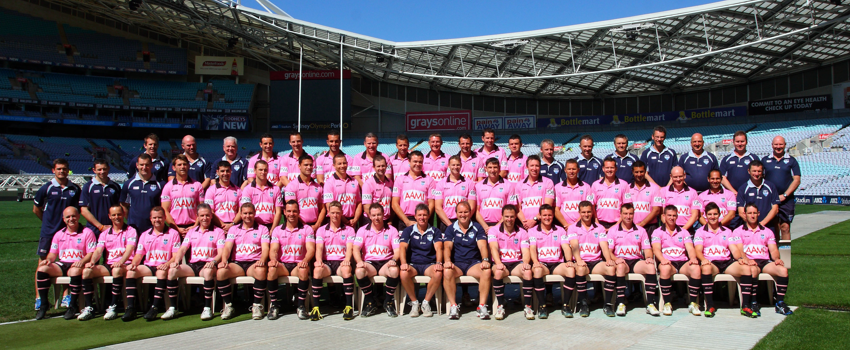

All time* first grade match official statistics

Referee – all time |  |  |  | Touch Judge*
Rank | Name | No. |  | Rank | Name | No.
1 | Bill Harrigan | 393 |  | 1 | Steve Chiddy | 325
2 | Col Pearce | 343 |  |  | Steve Betts | 325
3 | Steve Clark | 314 |  | 3 | Max Tomsett | 308
4 | Tony Archer** | 292 |  | 4 | Steve Carrall** | 301
 | Tim Mander | 292 |  | 5 | Russell Turner** | 290
6 | Sean Hampstead | 290 |  | 6 | David Abood** | 279
7 | Paul Simpkins | 284 |  | 7 | Colin Jones | 275
8 | Shayne Hayne** | 276 |  | 8 | Bryan Gately | 268
9 | Kevin Roberts | 273 |  | 9 | Paul Holland** | 267
10 | Darcy Lawler | 272 |  | 10 | Brian Wiseman | 264
11 | Jack O’Brien | 262 |  | 11 | Col White | 258
12 | Tom McMahon Jnr | 246 |  |  | Ian McCall | 258
13 | Graham Annesley | 244 |  | 13 | Ted Pepper | 232
14 | Greg McCallum | 241 |  |  | Bolton | 232
15 | Laurie Bruyeres | 239 |  | 15 | Jack Turner | 226
16 | Eddie Ward | 217 |  | 16 | Michael Howell | 224
17 | Tom McMahon Snr | 211 |  | 17 | Carl Gilchrist | 219
18 | George Bishop | 208 |  | 18 | Martin Weekes | 215
19 | Keith Page | 206 |  | 19 | Frank Walsh | 213
20 | Mick Stone | 193 |  | 20 | Brian Barry | 213
21 | Webby Neil | 192 |  |  | Ross Picard | 213
22 | Jason Robinson** | 190 |  | 22 | Jeff Younis** | 210
** Up to & including Qualifying Finals 2012. * Includes all Touch Judge first grade statistics after 1952 NSWRL season

Video referee – all time
Rank | No of games | Name
1 | 431 | Chris Ward**
2 | 302 | Graeme West
3 | 279 | Phil Cooley**
4 | 210 | Tim Mander
5 | 190 | Steve Clark**
6 | 158 | Paul Simpkins**

State of Origin officials
Year | Referee(s) | Touch Judges | Video Referee(s)
1998 | Bill Harrigan | Col White  David Goener | John Gocher
1998 | Bill Harrigan | Leon Edney  Steve Betts | Chris Ward
1998 | Bill Harrigan | Steve Nash  Col Jones | John Yard
1999 | Bill Harrigan | Steve Betts  John McCormack
1999 | Steve Clark | Phil Cooley  Col White | Chris Ward
1999 | Steve Clark | Col Turnell  Steve Nash | Noel Bissett
2000 | Bill Harrigan | Phil Cooley  Steve Nash | Chris Ward
2000 | Bill Harrigan | Phil Cooley  Steve Chiddy | Eddie Ward
2000 | Bill Harrigan | Phil Cooley  Steve Chiddy | Graeme West
2001 | Bill Harrigan | Phil Cooley  Alan Fallah | Mick Stone
2001 | Bill Harrigan | Phil Cooley  Alan Fallah | Eddie Ward
2001 | Bill Harrigan | Phil Cooley  Darren Gocher | Chris Ward
2002 | Bill Harrigan | Darren Gocher  Allen Foster | Chris Ward
2002 | Bill Harrigan | Alan Fallah  Steve Chiddy | Eddie Ward
2002 | Bill Harrigan | Steve Chiddy  Allen Foster | Chris Ward
2003 | Bill Harrigan | Darren Gocher  Pat Reynolds | Eddie Ward
2003 | Bill Harrigan | Darren Gocher  Glyn Henderson | Phil Cooley  Steve Clark
2003 | Bill Harrigan | Darren Gocher  Glyn Henderson | Eddie Ward  Tim Mander
2004 | Sean Hampstead | Steve Chiddy  Steve Carrall | Steve Clark  Graeme West
2004 | Sean Hampstead | Steve Chiddy  Steve Carrall | Tim Mander  Graeme West
2004 | Paul Simpkins | Steve Chiddy  Steve Carrall | Graeme West  Sean Hampstead
2005 | Paul Simpkins | Steve Chiddy  Steve Carrall | Graeme West
2005 | Steve Clark | Steve Chiddy  Steve Carrall | Graeme West
2005 | Paul Simpkins | Steve Chiddy  Steve Carrall | Graeme West

Year | Referee(s) | Touch Judges | Video Referee(s)
2006 | Sean Hampstead | Matt Cecchin  Steve Carrall | Graeme West
2006 | Steve Clark | Russell Turner  Rod Lawrence | Graeme West
2006 | Steve Clark | Russell Turner  Rod Lawrence | Graeme West
2007 | Paul Simpkins | Steve Carrall  Russell Turner | Bill Harrigan  Tim Mander
2007 | Shayne Hayne | Steve Chiddy  Steve Carrall | Bill Harrigan  Tim Mander
2007 | Paul Simpkins | Steve Chiddy  Russell Turner | Bill Harrigan  Tim Mander
2008 | Tony Archer | Steve Chiddy  Paul Holland | Bill Harrigan  Tim Mander
2008 | Tony Archer | Russell Turner  Gerard Sutton | Bill Harrigan  Tim Mander
2008 | Tony Archer | Steve Chiddy  Russell Turner | Bill Harrigan  Tim Mander
2009 | Tony Archer  Shayne Hayne | Jeff Younis  Steve Chiddy | Bill Harrigan  Tim Mander
2009 | Tony Archer  Shayne Hayne | Paul Holland  Russell Turner | Bill Harrigan  Tim Mander
2009 | Tony Archer  Shayne Hayne | David Abood  Steve Carrall | Paul Simpkins  Sean Hampstead
2010 | Tony Archer  Shayne Hayne | Paul Holland  David Abood | Bill Harrigan  Paul Simpkins
2010 | Tony Archer  Shayne Hayne | Paul Holland  David Abood | Tim Mander  Bill Harrigan
2010 | Tony Archer  Shayne Hayne | Paul Holland  David Abood | Tim Mander  Bill Harrigan
2011 | Tony Archer  Jared Maxwell | Jeff Younis  Steve Carrall | Tim Mander  Chris Ward
2011 | Shayne Hayne  Jared Maxwell | Paul Holland  Daniel Eastwood | Sean Hampstead  Russell Smith
2011 | Tony Archer  Shayne Hayne | Paul Holland  Daniel Eastwood | Steve Clark  Paul Simpkins
2012 | Ben Cummins  Matt Cecchin | Paul Holland  Jeff Younis | Sean Hampstead
2012 | Ben Cummins  Tony Archer | Russell Turner  David Abood | Steve Clark  Paul Simpkins
2012 | Ben Cummins  Tony Archer | David Abood  Russell Turner | Steve Clark  Russell Smith

NRL Grand Final Officials

Year | Referee(s) | Touch Judges | Video Referee(s)
1998 | Bill Harrigan | Steve Betts  John McCormack | Ian Parnaby
1999 | Bill Harrigan | Col White  John McCormack | Chris Ward
2000 | Bill Harrigan | Steve Lyons  Phil Cooley | John Gocher
2001 | Bill Harrigan | Shayne Hayne  Steve Richards | Chris Ward  Mick Stone
2002 | Bill Harrigan | Shayne Hayne  Steve Richards | Mick Stone  Ian Parnaby
2003 | Bill Harrigan | Steve Carrall  Glyn Henderson | Phil Cooley  Steve Clark
2004 | Tim Mander | Steve Chiddy  Matt Cecchin | Graeme West  Chris Ward
2005 | Tim Mander | Steve Carrall  Matt Cecchin | Graeme West  Mick Stone
2006 | Paul Simpkins | Steve Carrall  Rod Lawrence | Chris Ward  Bill Harrigan
2007 | Tony Archer | Russell Turner  Steve Chiddy | Bill Harrigan
2008 | Tony Archer | Steve Chiddy  Jeff Younis | Bill Harrigan  Steve Clark
2009 | Tony Archer  Shayne Hayne | David Abood  Paul Holland | Bill Harrigan
2010 | Tony Archer  Shayne Hayne | Paul Holland  Jeff Younis | Bill Harrigan  Tim Mander
2011 | Matt Cecchin  Tony Archer | Paul Holland  Daniel Eastwood | Sean Hampstead  Russell Smith
2012



